CYBERSECURITY TOOLS · WEEKLY LEARNING TRACK
Nmap Reference Documentation
Module 8 — Exploring Nmap Scan Options

Prepared by Emmanuel Aidoo
Kali Linux · Nmap 7.98
September 23, 2026

Contents
1 Packet Fragmentation (-f) 3
2 Source Port Selection (--source-port) 4
3 Decoy Scanning (-D RND:5) 5
4 Randomized Host Ordering (--randomize-hosts) 6
5 Key Takeaways 7

Objective: understand the purpose and basic usage of four Nmap options, documenting the commands and their results with screenshots.
Topic: packet fragmentation, source port selection, decoys, and randomized host ordering. All four scans below target the same lab host used throughout this track, 173.230.138.70, except the last, which sweeps the 10.0.2.0/24 lab network.

1 Packet Fragmentation (-f)
● ● ●
$ nmap -f 173.230.138.70
What I learned
The -f option fragments supported scan probes into smaller IP fragments. This can affect how packet filters handle the traffic, but it does not guarantee a firewall bypass.
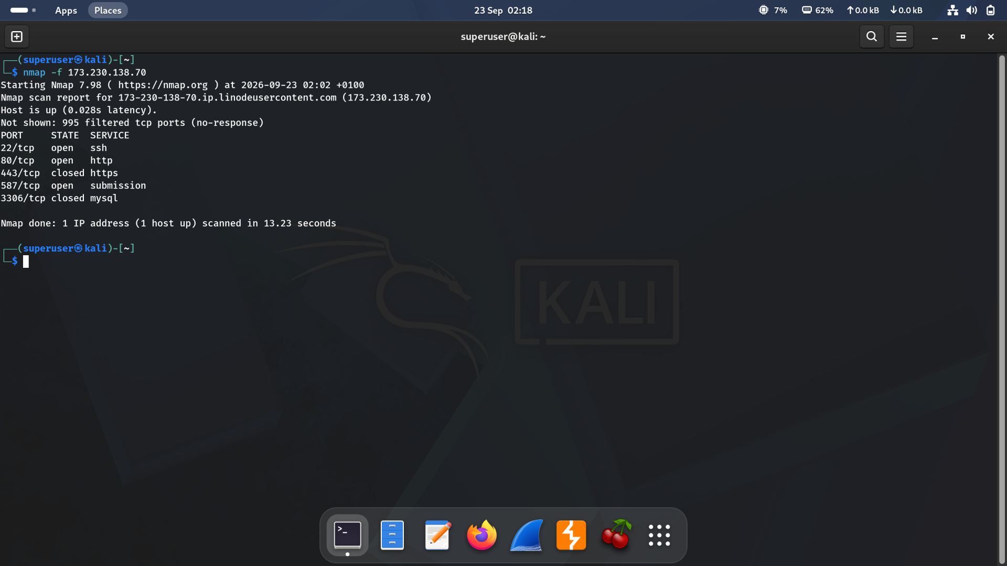
Figure 1 · Fragmented scan against 173.230.138.70
Result summary
Port | State | Service
22/tcp | open | ssh
80/tcp | open | http
443/tcp | closed | https
587/tcp | open | submission
3306/tcp | closed | mysql

My observation
995 of 1000 ports filtered, with 22, 80, and 587 open, the same three ports this host has shown open across most earlier modules. Fragmentation finished in 13.23 seconds, close to a normal scan's speed, and didn't change which ports were detected as open, closed, or filtered. That lines up with what I learned: fragmenting the probes changed how the packets were shaped in transit, not what the scan actually found here.

2 Source Port Selection (--source-port)
● ● ●
$ nmap --source-port 80 173.230.138.70
What I learned
This option sets the source port of supported probes to 80. It does not restrict the scan to destination port 80 or turn the probes into HTTP traffic.
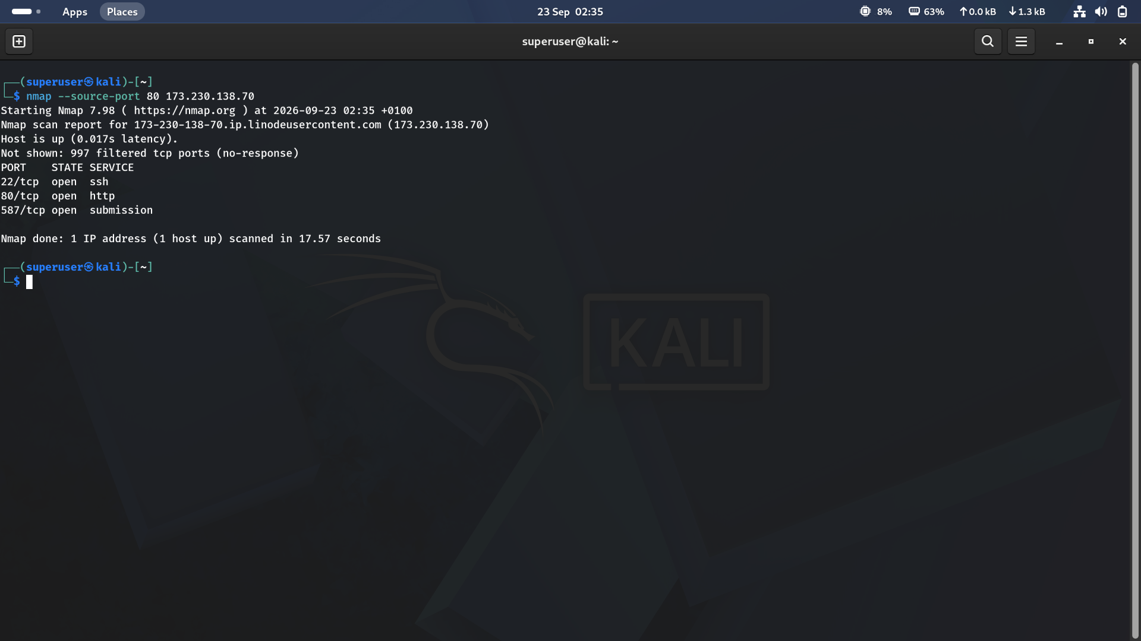
Figure 2 · Scan with the source port forced to 80 against 173.230.138.70
Result summary
Port | State | Service
22/tcp | open | ssh
80/tcp | open | http
587/tcp | open | submission

My observation
Nmap still probed all 1000 destination ports and returned the same 22, 80, 587 open result as a plain scan, confirming that forcing the source port to 80 had no effect on which destination ports got scanned. Only 997 ports came back filtered here instead of 995, and the whole scan ran a bit faster (17.57 seconds), small run-to-run differences rather than anything caused by the source port itself.

3 Decoy Scanning (-D RND:5)
● ● ●
$ nmap -D RND:5 173.230.138.70
What I learned
-D enables decoy scanning, and RND:5 generates five random decoy IP addresses. Supported probes appear to originate from those addresses as well as my real IP. Decoys do not make the scan anonymous.
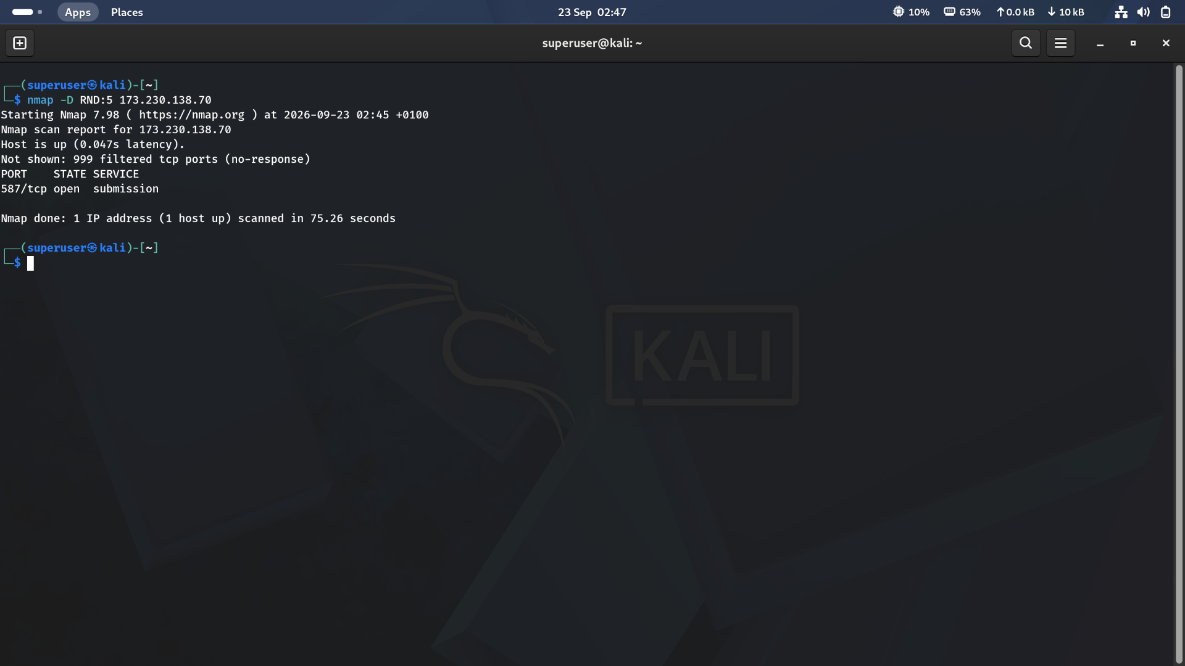
Figure 3 · Decoy scan using five random decoys against 173.230.138.70
Result summary
Port | State | Service
587/tcp | open | submission

My observation
This is the one result in the module that surprised me. Only port 587 came back open, with 999 ports filtered, instead of the 22, 80, 587 trio every other scan of this host has shown. The scan also took 75.26 seconds, roughly four to five times longer than Sections 1 and 2. My reading is that sending every probe from six addresses at once (five decoys plus my real one) multiplies the total traffic the target sees, and that extra load is the likely reason 22 and 80 didn't come back as confirmed open this time. The normal Nmap report doesn't show how the decoys actually appeared in the target's logs, only a packet capture on the target side could confirm that, but the timing and the thinner result both point to the decoys adding real overhead rather than just padding the scan for free.

4 Randomized Host Ordering (--randomize-hosts)
● ● ●
$ nmap --randomize-host 10.0.2.15/24
What I learned
This option randomizes the order in which target hosts are scanned. It controls host ordering, not port ordering.
NOTE
The command actually run used --randomize-host (singular); Nmap's documented option is --randomize-hosts (plural). It still ran, which means Nmap accepted the shorter form as an unambiguous abbreviation of the full option name.
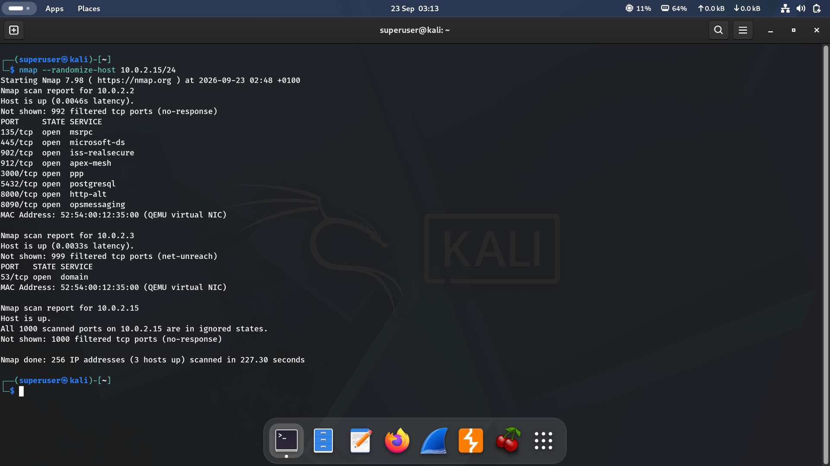
Figure 4 · Randomized-order sweep of the 10.0.2.0/24 lab network
Result summary
Host | Open Ports | Notes
10.0.2.2 | 135, 445, 902, 912,  3000, 5432, 8000, 8090 | NAT gateway, same host seen in earlier CIDR scans; 8000 (http-alt) is a port this host hasn't shown open before
10.0.2.3 | 53 (domain) | NAT DNS relay, consistent with every earlier scan of this host
10.0.2.15 | None, all 1000 filtered | The scanning machine itself

My observation
3 hosts detected out of 256 addresses, matching every earlier sweep of this /24, and the report still listed them in ascending order: .2, then .3, then .15. With only three live hosts, a random shuffle has just six possible orderings, so landing on the sequential one once isn't strong evidence either way; I'd want to run this a few more times and compare before concluding randomization is or isn't visibly working. The scan also took 227.30 seconds, far longer than the plain CIDR sweep back in Module 3, since this run scanned full ports on each live host rather than just checking who was up.

5 Key Takeaways
- RST means TCP Reset; receiving it during a SYN scan normally indicates a closed port.
- These options change scan behavior without necessarily changing the output format or port results — fragmentation and the source port swap left this host's results essentially unchanged.
- Decoys are the exception worth watching closely: adding five decoys roughly quadrupled the scan time and returned fewer confirmed open ports, a reminder that decoys add real network load even though they don't add real anonymity.
- Nmap screenshots document commands and results; packet captures are needed to examine the underlying traffic directly — especially to actually see how decoy traffic looks to the target.
- A single run isn't enough to confirm host randomization is taking effect; with only a handful of live hosts, sequential-looking output can happen by chance and needs repeated runs to interpret.

